Should a boy have been sentenced to seven years in an adult court on conflicting and unreliable evidence that was heard in a trial more than three years after the event?
Read this summary of the trial evidence and be the judge.
A quiet afternoon in Anula
The first Monday in May is a public holiday in Darwin, capital of the Northern Territory. In the morning, human rights causes are proclaimed in the traditional May Day March and in the afternoon a festival on Mindil Beach celebrates the beginning of the Dry Season, and the end of the long and humid Wet Season. The crisp cooler weather under blue skies is a welcome change from the steamy months from October to April when deadly box jelly fish make swimming hazardous. Despite the holiday activities taking place in the inner suburbs, Monday May 5th, 2003, had been a long and boring day for two adolescent girls from Sanderson High School. It was to become a day that changed the lives of the two friends from the Darwin northern suburbs and an Aboriginal boy from adjoining Rapid Creek forever.

The older of the two girls, Sue (the complainant), usually lived with her parents at the
Darwin RAAF base in Winnellie. She was born in September, 1989, making her age 13-years-and-8-months in May, 2003. Her brother was 15 and her sister was 16. On this first weekend in May she was staying at her best friend Anne’s home in Enterprise Street, Anula. Anne is four months younger than Sue (the complainant).

On the Sunday night the two girls baby-sat at a neighbour’s house and then spent some of the Monday swimming in the pool at Anne’s home. Because Sue was due home by 6pm, Anne says the girls walked down to the bus stop between Clifton Court and Yanyula Drive on Springhill Road ‘at about quarter to four’ to catch the Number 3 bus, presumably the 3.45pm bus from the Casuarina terminus. Anne says they waited for a while at the first bus stop until they became bored, then walked down Yanyula Drive to the bus stop out the front of Anula Shops. She said, ‘We just walked there and we started walking back.’ While they were walking back to the Springfield stop, a bus passed them. They then decided to wait for the next bus. The Number 3 buses leaves the Casuarina terminus at 3.45, 4.50 and 5.55 on public holidays and takes about five minutes to reach Anula. The timetables are displayed on the bus stops. Anne had her mobile phone to check the time.

Every Monday at 5.30pm the Brothers rugby league team held their training on the Anula school oval and the players began to arrive as usual that afternoon. Tae Kwan Do practice was also due to begin at 5.30 pm in the school assembly area and children were playing in the school sandpit. The school caretaker for the last four months had spent the whole day on the school grounds where he shared a caravan with his partner.

The boy at the bus stop
Meanwhile the two girls waiting at the bus stop were approached by a boy of about 15 who asked for $2 for a bus fare. Sue said, ‘No probs’, and gave him money from her purse. Anne says he then walked away towards the shops, but returned in about ten minutes. At the trial the defence lawyer, Mr Woodcock, asked Anne: ‘Do you remember him telling Sue that his name was Graham X ?’ Anne’s answer was ‘Yes.’ Anne said that the boy was talking to Sue for about ten minutes but for some reason Anne didn’t take much notice of what the two of them were saying until Sue said she was going to ‘go for a walk or something like that… She said she would be back in about 5 minutes.’

Sue left her bag with Anne at the bus stop and walked off with the boy. Anne says she lost sight of them when they turned right into Yanyula Drive. Anne estimated that she waited for about half an hour to forty-five minutes at the bus stop. She says checked the time on her mobile telephone. After waiting for so long, Anne walked down to Yanyula Drive to see where the couple had gone, and saw them walking back along Yanyula Drive ‘from Union Terrace sort of way,’ towards where Anne was waiting in Springhill Road. After seeing that Sue was returning with the boy, Anne walked back to the Springhill Road bus stop. While she had been waiting, she says that another bus had gone past (4.55pm?). She says Sue came back to the bus stop with the boy and the boy walked away.

Sue tells a very different story to her friend Anne. She said that at about 1pm the girls walked over to a shopping centre on McMillans Road, and then back for a swim. Sue says that they left the house for the bus stop to catch the 4.50 bus due at 4.55pm. After they arrived at the bus stop on Springhill Road they realised they had missed their bus so they decided to walk along Yanyula Drive to Anne’s friend, Ted’s house, in Wandi Crescent, not far from the Anula shops. Ted wasn’t home, so the girls walked back to the first bus stop. Sue was carrying her overnight backpack with her

At the Springhill Road bus stop, a boy approached them and asked for money, but according to Sue they said they had nothing except her bus fare. Sue says he began asking them questions about their background, even asking if they were virgins. Sue says he introduced himself as ‘Sean Jones’ and said he lived in Rapid Creek (where Graham X lived with his grandmother). Sue and Anne knew Sean Jones so ‘they knew he was lying.’ However, at the trial Mr Woodcock suggested that the boy only asked if the girls knew Sean Jones, because this name was written in graffiti on the bus stop. Sue then said the boy asked how to get to a particular street across from the school. . She did not remember the name of the street - only that it started with a ‘B’. Sue says the girls ‘just wanted to get rid of him’ because they were ‘getting scared and worried because some of the questions were really personal.’ The above account is not collaborated in any way by Anne’s evidence.

Sue says Anne knew the street. Anne had been delivering pamphlets in the Anula area. Sue continued, ‘[Anne] was too tired and didn’t want to walk there to show this guy,’ Sue then said she would take him, ‘because she was fed up with his nagging.’ According to Sue, Anne told her ‘to walk through the school the way we normally go to the oval and it’s directly opposite.’ (The only street beginning with a ‘B’ in the area is Brock Court, off Tolmer. There was no suggestion that Brock Court was the street in question). Anne told the police she only heard her friend and the boy saying ‘something about Tolmer Street.’

Tolmer Street is only one street further on from Wandi along Yanyula Drive. The street is directly opposite the oval but it is more easily reached by following the Yanyula Drive footpath to the Anula shops, in the direction the girls had previously been walking. To point out the street by going through the school requires first walking along Yanyula Drive in the opposite direction to the school entrance. The path through the school also goes between the school buildings and has trees on either side with bushy areas and playgrounds. Sue says she was ‘following Anne’s instructions’ although Anne did not remember giving any directions or being asked about any street. Sue claims she walked behind the boy who had scared her with so many personal questions until they got to a deserted area near a group of trees. Once there, she pointed across to Yanyula Drive and told the boy, ‘There’s your street … where there’s another street that comes off this.’

By the time Sue returned to the bus stop where her friend had been waiting for at least 30 minutes, the next bus had gone past. Sue says she looked behind her and the boy was following, ‘but in the distance.’ Sue claims the boy saw her sit down next to Anne and then she saw him walk off towards Anula shops. (Anne said the couple returned together).
Witnesses in the school yard
The case against Graham X hangs on whatever occurred in the school grounds between 5.15 and 5.45pm that afternoon. Not surprisingly with all the activities taking place that afternoon, there were two witnesses. The first was a man walking from Malak and cutting through the school grounds on his way to rugby practice that was due to begin at 5.30pm on the Anula School oval. This man was surprised to see a ‘young lad and a girl having sexual intercourse’ near some bushes in the school grounds. He could see the boy, ‘from the middle of his back to his feet.’ The witness continued, ‘He was laying down on top of the girl and I seen his bottom, his bum … in a sexual motion, sort of up and down on the girl.’

After a glance, the witness walked on, giving a loud cough as he passed. When he looked back he saw the boy getting up and the girl sitting on the ground ‘pulling some clothing on.’ He glanced back after ‘5 to 10 seconds’ and saw the boy move from about a metre away from the girl to ‘across the road [in the school] to wash his hands’ at the taps. Mr Woodcock asked the witness if he ‘felt the need to go over and do anything’ when he saw the couple having intercourse on the ground. The witness did not think there was anything ‘untoward’ in what he saw, apart from it being wrong to be having sex in that place. The only action he took was to continue down the path to his rugby training.

The second witness was the school caretaker who says he left his caravan on the school grounds at about 5pm to do a check. At that time the Taekwondo group was setting up in the assembly area. The caretaker saw what looked like, from the back, a boy and a girl of high school age walking side-by-side away from him and around the school buildings out of his sight. He watched them walking for perhaps less than a minute They were moving their heads towards each other, as though talking. From the caretaker’s description, the boy fitted the description of Graham X and was wearing the same clothing. The caretaker returned to his caravan to tell his partner he was going to check around the back of the school to Yanyula Drive. When he reached the front of the school the caretaker very briefly saw the same boy, of Aboriginal appearance, and a white girl. They were now sitting together on the front rail of the school boundary facing toward the road ‘at the T junction’ [with Ford Street?], apparently talking, although he could not hear them. The caretaker thought he first saw the couple at about 5pm and the next time at about 5.15 to 5.20pm.

Sue’s version of what happened in the Anula School grounds
Sue said that after they had passed the school buildings she pointed out the street across the oval but the boy wasn’t interested; he stood in front of her and grabbed her arm. However, no street is visible through the dense vegetation growing between the school buildings and the oval, and the avenue of trees around the oval (see photos below and on the photos page).
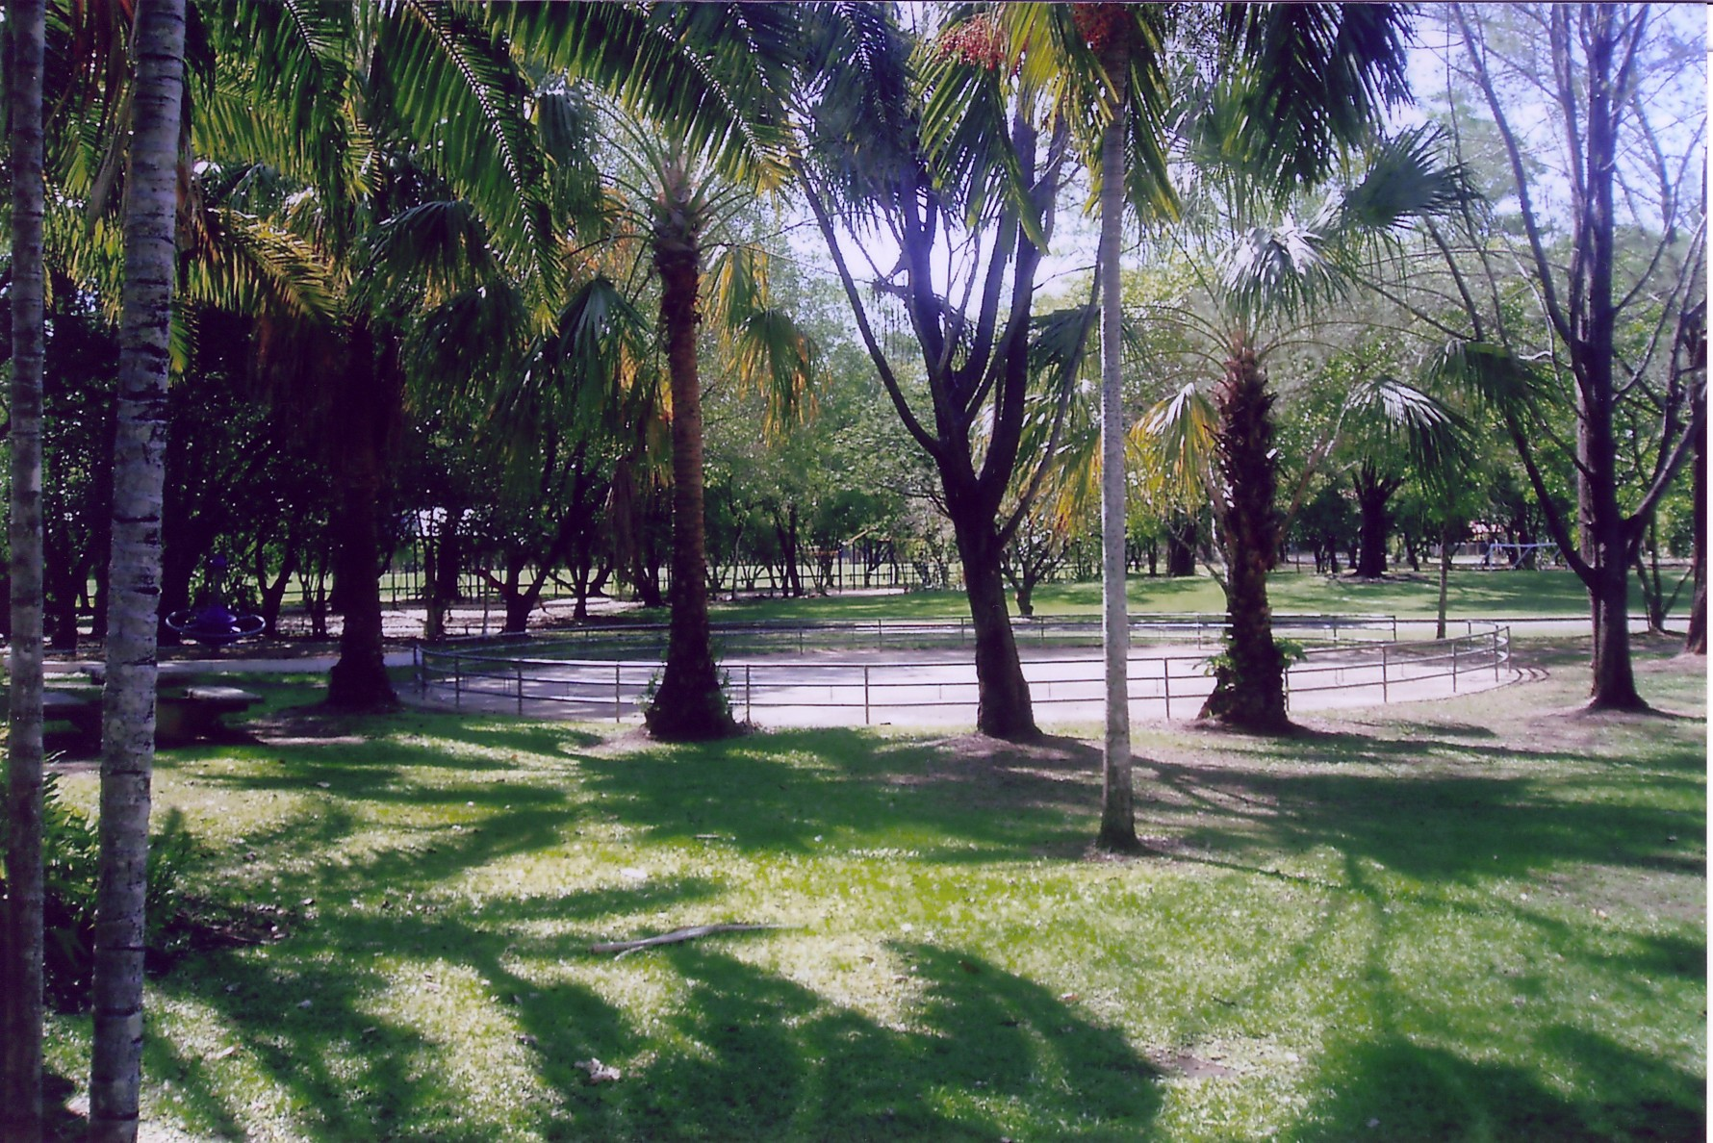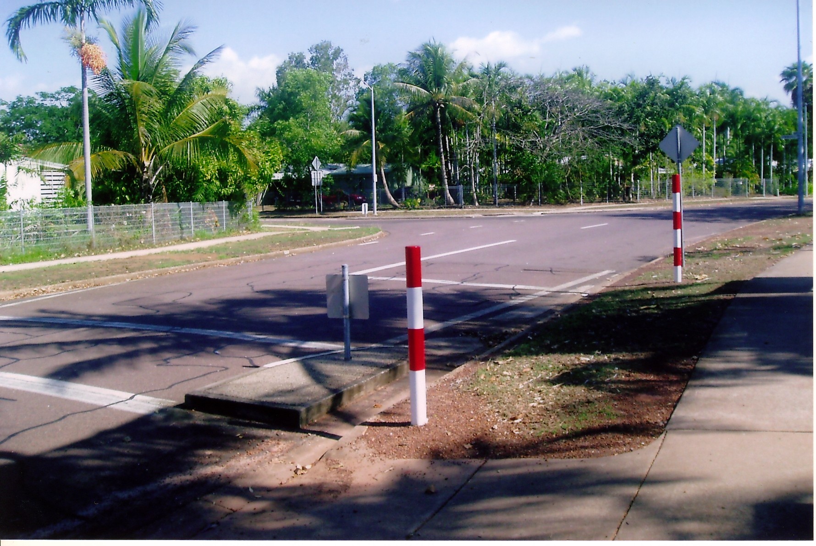
Above left: View from behind Anula Primary School buildings looking across parking area to school oval. Sue says she pointed to ‘a street’ but no street is visible. Above right: Looking back from the school entrance to the corner of Springhill Street. Sue left her friend at the Springhill Street bus stop (see separate photo page) and walked into the school with the boy through this entrance to show him ‘a street.’ She later walked back with him to the bus stop.

Sue claims the boy then put his hand down her shorts and slid his finger into her vagina. She said it felt really painful, ‘like more than one finger.’ She then grabbed his hand from her pants and pushed it away. Sue said she was then pushed to the ground and the boy used his knees to spread her legs open.

In her statement to the police Sue said, ‘He started undoing my shorts and I told him to piss off but he didn’t stop.’ Mr Woodcock asked at the trial if her voice was loud enough for someone else who was nearby to hear. Sue said, ‘It was loud enough for him to hear …my body wasn’t re-acting … It was in a more panicky tone, but I couldn’t quite yell.’ He let go of her arms as he pulled down her shorts and underwear. Sue explained that although he let go, she felt ‘really weak and my body had frozen up and like it wasn’t responding and I couldn’t do anything.’

Sue said the boy forced his penis ‘inside her vagina … but it didn’t go in at first.’ She kept saying ‘Stop it.’ She told the trial that his penis was ‘soft at first but then it got really hard … it kept going in and out and it felt like he ejaculated in me.’ In the police statement she said, ‘He didn’t undo anything on his shorts, he just pulled [his penis] out and over the top of his shorts. I could see that his penis was soft then he went back to lying on top of me and inserted it into my vagina.’ When he had finished, as Sue was getting dressed, she ‘saw blood coming out of her vagina.’ As she started to stand up ‘I was telling him I had to go and the bus was coming … as I was still talking he shoved his penis into my mouth … he hadn’t put his penis away and his penis was still hard…’ Again she says that he just held his penis over the elastic of his shorts (did not have his shorts off). At this point Sue added in 2006 that she heard footsteps and the boy let her go. She said she then started running off, back towards the bus stop. It was as she was running away he supposedly said ‘this will be our little secret.’

Emotional distress sways the jury
In the trial there was much emphasis on the legal question of ‘distress.’ That is, the facial expression and emotions shown by Sue after the incident in the school grounds. Mr Woodcock objected to statements by witnesses that said Sue ‘was in shock’, ‘she was not herself,’ she was crying, she was hysterical etc. Under the law, distress carries little weight in terms of proof of the actual facts. As Mr Woodcock suggested to the Judge, ‘Distress is something that plays to the emotions of the jury without having safely any probative value [doesn’t prove anything].’ Certainly the jury heard many vivid descriptions of Sue’s emotions after she returned to Anne at the bus stop, later at Anne’s house and after her mother and the police were called. The policewoman began explaining the relationship to Sue’s ‘state of shock’ and her memory until Mr Woodcock objected: ‘[Can] the witness stick to the evidence your Honour - she’s not an expert as to memory.’

Mr Woodcock objected to the prosecution’s wish to present evidence about Sue’s change in behaviour after these events took place, ‘in relation to her school activities and the like … ongoing behavioural changes,’ The Chief Justice agreed and commented: ‘[I] cannot see how that could be said to point in the direction of the sexual activity without consent as opposed to consensual activity followed by regret and a whole range of other emotions that would come out of a police investigation.’

Soon after the police witness described Sue’s facial expression when giving her statement, ‘looking as if it was traumatic.’ Immediately Mr Woodcock objected ‘on the basis that distress has already been put before the jury.’ However, this time the Chief Justice did not accept the objection. He stated: ‘This is nothing to do with distress. This is directly relevant to the assessment by the jury of the statement they are about to hear. So the child’s condition at the time the statement was taken is a relevant matter.’

At the trial the prosecution repeated referred to Sue’s emotional state. Her mother described her daughter’s ‘hysterical sobbing.’ Anne also offered various descriptions of Sue’s emotional state. Firstly, when Sue returned, Anne said, ‘I seen her kind of looked shocked.’ Anne expanded the description, saying; ‘She was like all red in the face and her eyes were a bit bloodshot and she was kind of shaking a little bit and like she just didn’t seem herself.’ Later the prosecutor prompted Anne, ‘Sue looked, should have [inaudible]…’ and the Chief Justice completed the question, ‘Shocked.’ The prosecutor continued: ‘Shocked… when you looked up and saw her looking shocked, could you see anybody else nearby?’ Anne replied, ‘Yes, the same boy.’ And added, ‘[He was] still next to her.’

The Police are called
According to Anne, Sue said nothing about what had happened as the girls walked back to the house (not ran as Sue claims). When the two friends went into Anne’s bedroom Anne again asked what had happened. Sue said did not want to call the police but Anne ‘ended up getting her to call her mother and then we called the police.’ Mr Woodcock asked Anne: ‘Did she say she didn’t want to tell her mother?’ Anne replied: ‘’She just said she didn’t want anyone to know about it.’
Woodcock: ‘Okay. And you insisted that she had to tell someone about it?’
Anne: ‘Yes.’
Woodcock: ‘And you called the police?’ Anne: ‘Yes.’
The call was noted as being received at the police station at 5.43 pm. Graham X was picked up by the police at a bus stop outside the Anula shops at 6.05 pm (a bus was due at that time). He was not hiding or resisting in any way.

Sue made a six-page statement to the police at about 11pm that night. Once again Sue’s 2003 statement of the events after she left the school ground differed in many important ways to Anne. For a start, Sue said the two girls ran back to the house. As they were running, Sue claimed that she told Anne what had happened. At the house, according to Sue, Anne told her mother and the mother rang the police. Anne’s mother also told Sue to ring her mother. Sue told the jury: ‘I was still crying, so [my mother] asked me what was wrong and all I said was I had been raped and she screamed on the other end…’

The Doctors’ evidence
When Sue got up from the ground to put her clothes back on, she noticed that she was bleeding from her vagina. As she said, when she put her clothes back on, there was ‘a lot of blood’ on her panties. Questions about the medical investigation into two genital injuries (a scratch and bruising) took up some time during the trial and undoubtedly influenced the jury’s deliberations.

Dr Gurmeet Rajinder Singh has been an on-call medical officer at the Sexual Assault Referral Centre (SARC) in Darwin since 2000. After being asked by the prosecution to describe Sue’s emotional state, the doctor described her examination of the girl’s genital area. Firstly, the blood was oozing from a ‘tear’, ‘abrasion’ or ‘laceration’ of ‘about one and a half centimetres’ which the doctor said, ‘probably accounts for the blood I saw on her thighs.’ Beyond the abrasion, ‘on the surface of the hymen’ says Dr Singh, was what she described as a ‘haematoma,’ or a bruise, where the skin is intact with blood visible under the surface. Both injuries lined up as though caused by the one action. However, the doctor did not examine the hymen by sight or by colposcope. As Dr Singh said, ‘It was painful for Sue when I was trying to move the labia lips apart to actually have a closer look inside.’ In the doctor’s opinion the injury would have been painful when it occurred. Dr Singh noted that research indicates ‘one of the factors causing injury is the relative inexperience… Even so the chances of getting injured with consensual sex are much lower.’ Despite this finding, she could not rule out consensual sex as causing the injury.

Mr Woodcock for the defence called Dr Terrence Donald of the Royal Adelaide Women and Children’s Hospital to comment on the video made during Dr Singh’s examination. Dr Donald has been a forensic paediatrician since 1978. Dr Donald had studied Dr Singh’s notes, the transcript of her evidence and the record of the medical examination made on 5 May 2003. The examination was recorded on a DVD disk. A colposcope is used to make the recording as far as the cervix, using a bright light source with the colposcope a minimum of 30 centimetres from the outer skin surface – the colposcope doesn’t move. As the doctor explained, ‘All the manipulation occurs by manipulating the labia … unless there is acute injury … then I would leave that part of the examination for another 24 to 26 hours before I had another look.’ Viewing the colposcope recording provides magnification of the skin surface and an ability to pause the picture frame, giving as good, or better, a view as that of the actual examiner.

In legal terms penetration of the vagina includes any part of the internal or external female genitalia whereas medically ‘the vagina’ is the inner passage beyond the hymen. Using the analogy of a funnel Doctor Donald described the narrow spout as the vagina and the wide neck of the funnel as the ‘tissues which make up the entrance to the vagina. The hymen … is at the junction of the neck and the spout.’ While the neck of the funnel has a wider capacity, the laceration injury the doctor observed extended from the ‘lip of the funnel’ (the labia minora) towards the hymen at ‘the junction of the neck and the spout.’

Doctor Donald said he wouldn’t be surprised if there had been an injury to the hymen, but he couldn’t see it. He said he couldn’t see the hymen at all on the video recording. Judging by his experience, the scratch he observed was probably more likely caused by a fingernail. Explaining that all the tissues external to the hymen are medically called ‘the vestibule,’ the doctor said, ‘The finger didn’t get into the vagina as far as I could tell.’ He noted: ‘I don’t think that the kind of injury that I saw occurs through a penis moving through the neck of the funnel … because of the capacity of the neck to accommodate objects of a very large size.’ He added, ‘There was no evidence of any injury to the hymen.’ And, ‘no one, and this includes Dr Singh, got a good look at the hymen. She saw the haematoma [i.e. bruise] but clearly she didn’t get a chance to look at the opening [in the hymen] and investigate the edges of the opening for any sign of injury.’ After further questioning, the doctor said: ‘[The bruise] could be adequately explained by the penis pushing up against the outside … of the hymen.’

The main defect in Dr Singh’s video recording was a significant problem with the examination technique, probably caused by the girl experiencing discomfort because of the internal injury. Dr Donald told the court that in a situation like this he would re-examine a 13-year-old in two days ‘because by then things have settled down.’ He also questioned the value of statistics on sexual injuries when applied to individual cases. As he said, ‘You get situations where there’s a lot of force and no injury and situations where there doesn’t seem to be much force at all and there’s quite significant injury. Referring to both injuries being in line as Dr Singh noted, Dr Donald said: ‘If the injury was caused by, as I suggested, digital penetration, then it is not uncommon for the hymen to be bruised and sometimes even torn by a finger.’ He finished by repeating that he could not tell from the examination whether a penis would have been able to pass through the girl’s hymen without injury or not.

In addition to the doctor’s doubts, the senior Darwin Police forensic biologist gave evidence at the committal hearing on 20 February, 2006. She detected no semen on either the swab or the smear contained in the Sexual Assault Kit taken from ‘the victim in this case.’ The forensic officer said that the SARC doctors also took swabs of the girl’s left and right breasts. ‘No DNA was recovered from these swabs.’ However, DNA identical to Sue’s was later recovered from the boy’s underpants.

Changing memories
It is important to note that by the time of the trial in November 2006, 3½ years had passed since May, 2003, and witnesses’ memories had begun to fade. There was even some variance with evidence given at the trial and at the committal hearings in February 2006. Mr Woodcock claimed there were ten things that came to light in evidence given to the trial that were not in Sue’s original statement. The Chief Justice replied: ‘And saying therefore they should have doubt about her reliability?’

After more than three years, one would think that the statements given to police in 2003 would be more reliable than later memories. Sue had been receiving counselling since mid-2003. Some of her memories had ‘come back’ even more recently. In 2006 she remembered things in ‘nightmares’ that she felt were caused by the thought of having to return to Darwin from where her father now served in another state. In her nightmares, Sue remembered things she did not include in her original statement.

In 2006 Sue explained her forgetfulness in 2003 because she was ‘traumatised and under pressure.’ She added: ‘I’ve been trying to block it out but it just comes back.’ For example, she now remembers the boy having one hand up her top and on her breasts while his other hand was in her pants. In November 2006 when Sue was asked why she hadn’t mentioned this before she said, ‘I’ve been having nightmares lately with flashbacks, and it brought it back to me.’ She also now remembers the boy telling her after the alleged assault, ‘This will be our little secret.’

Neither of the above memories is in the statement given to police. Sue’s wording sounds as though it is from a counsellor’s text book on sexual abuse. Nor did Sue say in her original statement that she heard footsteps or that she pushed the boy’s hand away from inside her pants (which would require some strength against a bigger boy if it was not a consensual act).

Also in the police statement Sue said the boy was behind her and then walked in front of her and grabbed her right forearm. She confirmed this after being questioned by Mr Woodcock at the trial. However, she claimed in her evidence that she was walking behind the boy when he turned around at the deserted location and faced her before grabbing her by the arm.

Sue’s mother gave evidence that she was a ‘very naïve young girl … she’d never go out on her own. She was always with someone. She was always with her siblings. She loved reading, drawing, writing.’ The two girls gave their evidence in a closed court setting. Sue was always referred to as being just 13, although she was almost 13-years-and-eight-months. At the time the boy was less than 15-years-and-two-months of age. Although Graham X was a solid boy in 2003, weighing 60 kilograms and 170 centimetres in height, by 2006 he was standing in the dock as an almost fully grown 18-year-old man, in opposition to an girl portrayed as a naïve and traumatised ‘13-year-old.’ Perhaps more tellingly, he was black and she was white. Several times the accused was referred to as a ‘man.’ For example, in questioning Anne, twice Mr Woodcock referred to ‘the man you now know as Graham X’. His question was, ‘Do you remember the second time that the man you now know as Graham X came back and talked to Sue?’ After the verdict of guilty the Chief Justice observed: ‘This is a young man who is aged 18. He’s staring down the barrel of a long sentence of imprisonment.’

The verdict
To the lawyers the Chief Justice made it quite clear that any sexual penetration of the girl, being under the age of 16, was unlawful. He stated emphatically: ‘I propose to say to the jury there’s no suggestion that this was anything other than – in this situation – unlawful.’ However, according to the committal hearing, during the Police interview Graham X was asked, ‘So you happen to know how old she is?’
He replied, ‘Mm, yeah now I do.’
‘How do you know?’
‘Because I got told by youse.’
Graham X’s white step-father who saw the girl at the police station on the night of May 5th described Anne as smiling and looking ‘like a twenty-year-old.’

On 12th March the Chief Justice insisted on the inclusion of information from Graham X’s primary school records. The Judge noted: ‘Here’s a young man who on the face of this material has had difficulty in relationships at school with other students…’ He asked Mr Woodcock, ‘Do you have a problem with any of that?’ Woodcock replied that that he did, ‘Because this occurred when this person was 11 at primary school. The remoteness in time is such that it is completely irrelevant.’ Woodcock added, ‘It’s not the usual process in the sentencing. I’ve never seen it done before… we’re not sitting in continental Europe - this is not a free ranging inquiry.’ To which the Chief Justice replied, ‘Well, Mr Woodcock there’s a first time for everything … I’m not going to be sat here and treated like a mushroom.’ It seemed the whole span of Graham X’s 18 years was to be taken into account.

After the summing up on 22nd November 2006, the text of which is not provided in the available transcript copy, the jury retired at 12.45pm. At 6.16pm the jury returned for four minutes then retired again until 8.24pm when the Foreman pronounced that the jury had found the accused guilty of all charges. Firstly, sexual intercourse, namely digital vaginal penetration without consent. Secondly, sexual intercourse, namely penile vaginal penetration without consent. Thirdly, sexual intercourse, namely fellatio without consent.

The Chief Justice ordered that the sentence be back-dated to when Graham X was first taken into custody. He asked, ‘Can someone tell me when that was please?’ The prosecutor answered, ‘That was the day of the conclusion of the trial…’
Chief Justice: ‘So that’s the only time he’s been in custody? He wasn’t in custody? Arrested?’
The Judge was then advised that Graham X had not been in custody until the day of the guilty verdict on November 23rd, 2006.

Graham X had been on bail of $500 on his own recognizance since the committal hearing before Magistrate J Lowndes in Darwin on 20th February 2006 until the guilty verdict. In other words, a supposedly disturbed adolescent and violent rapist had been freely roaming the Darwin streets for 3½ years.

In his sentencing remarks the Chief Justice said, ‘I must sentence you on the basis of the facts consistent with the verdicts of the jury [guilty of three counts of rape] and which I am satisfied were proven beyond reasonable doubt.’ Despite the evidence of three witnesses contradicting the rape allegations, the Chief Justice then related almost verbatim the complainant’s discredited version of the events.

[The sentencing remarks are reproduced on the NT Supreme Court website: http://www.nt.gov.au/ntsc/doc/sentencing_remarks/2007/03/20070322.html ]

After admitting to Graham X that there had been a long delay between the commission of the crime in May 2003 and the laying of charges in August 2005, Judge Martin continued:

The delay was not your fault. I take into account the impact of the delay on you, but it is not a matter of great significance in arriving at an appropriate sentence … The sentence in total would have been longer if you had been a mature adult.
On Count 1 … I impose a sentence of three years and six months imprisonment… On Count 2 … I impose a sentence of six years and six months imprisonment… On Count 3, the act of inserting your penis into the victim’s mouth, I impose a sentence of five years imprisonment. Of this sentence, six months is to be served cumulatively on the sentence imposed on count 2.
The total period was seven years, commencing on November 23rd, 2006. The minimum Graham X must serve by law is five years. Since March 22nd he has been incarcerated in the Darwin Correctional Centre, better known as Berrimah Jail.
On 2nd February 2007 Graham X’s steady partner gave birth to their baby daughter.

Note: The names of the complainant and witnesses have been changed.
Send your comments to <Graham Xdefence@hotmail.com>

Note: This is not the actual name used in evidence.

